The given time integration method was solved to obtain $u{}_{2}$, $\dot{u}{}_{2}$, $\ddot{u}{}_{2}$, $u{}_{3}$, $\dot{u}{}_{3}$, and $\ddot{u}{}_{3}$ (code attached on subsequent pages)

**At node 2**:

**For $k=5$,**

* the following figure gives $u{}_{2}$ with respect to time $t$:

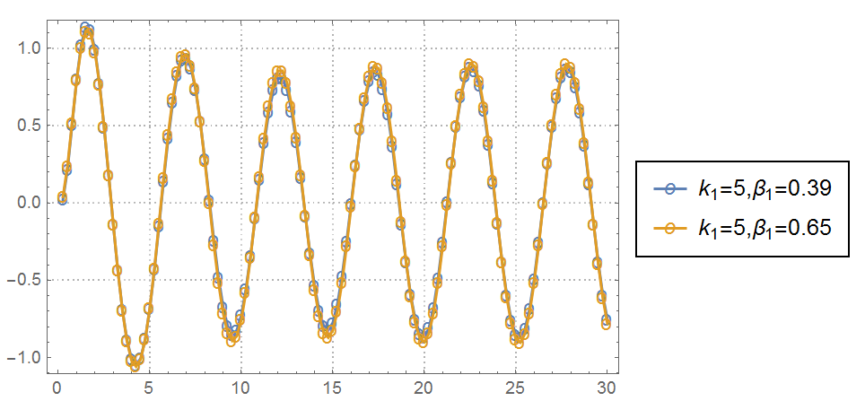

* the following figure gives $\dot{u}{}_{2}$ with respect to time $t$:

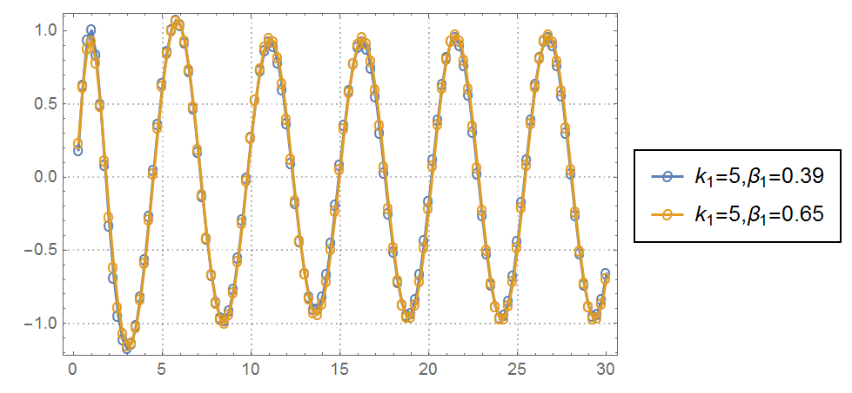

* the following figure gives with respect to time :

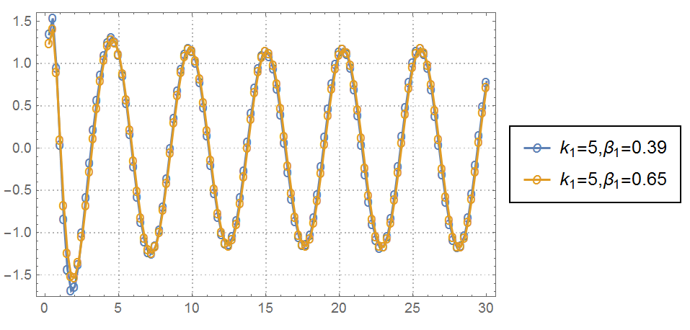

**For ,**

* the following figure gives with respect to time $t$:

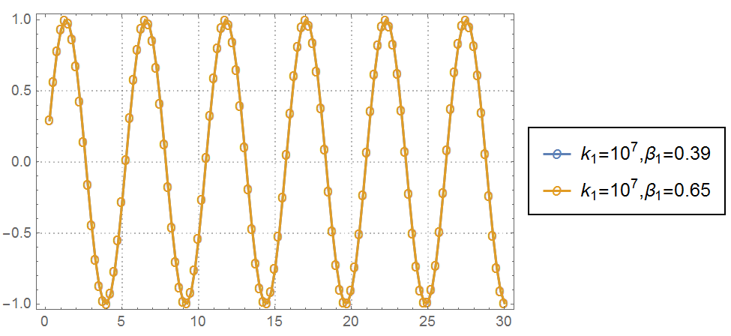

* the following figure gives $\dot{u}{}_{2}$ with respect to time $t$:

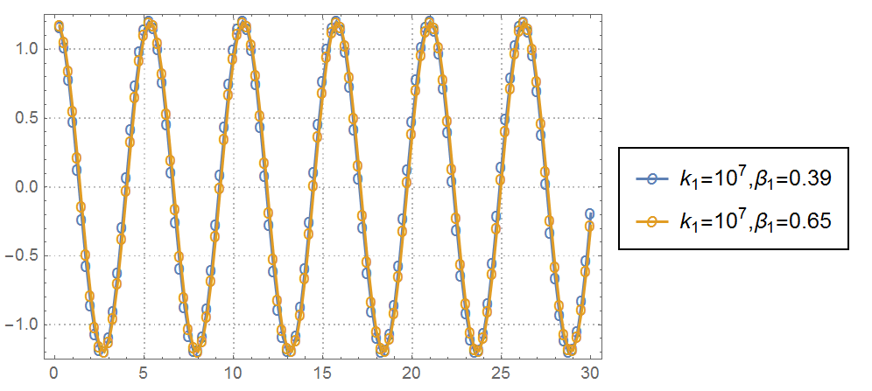

* the following figure gives $\ddot{u}{}_{2}$ with respect to time $t$:

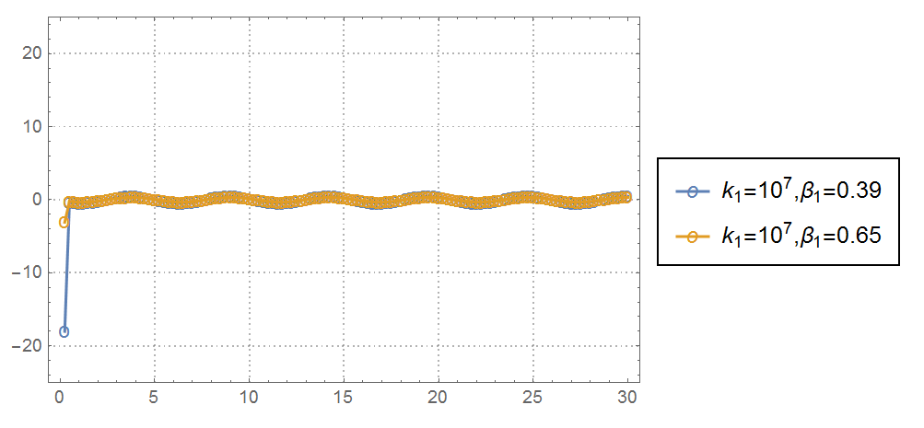

**At node 3**:

**For $k=5$,**

* the following figure gives $u_{3}$ with respect to time $t$:

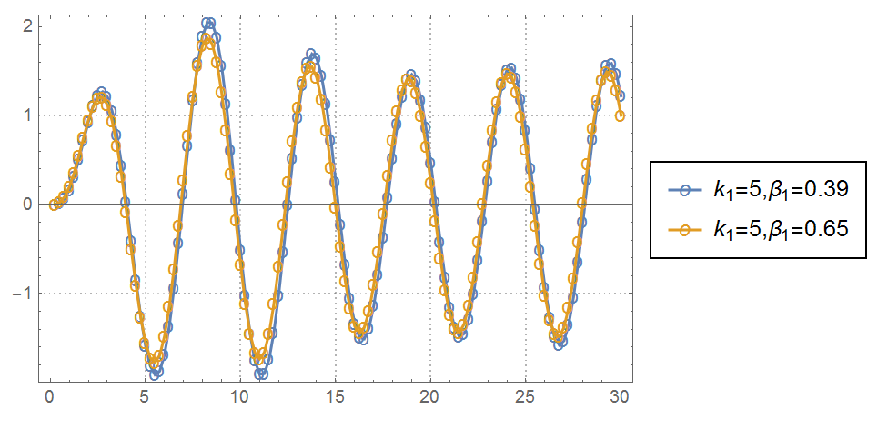

* the following figure gives $\dot{u}{}_{3}$ with respect to time $t$:

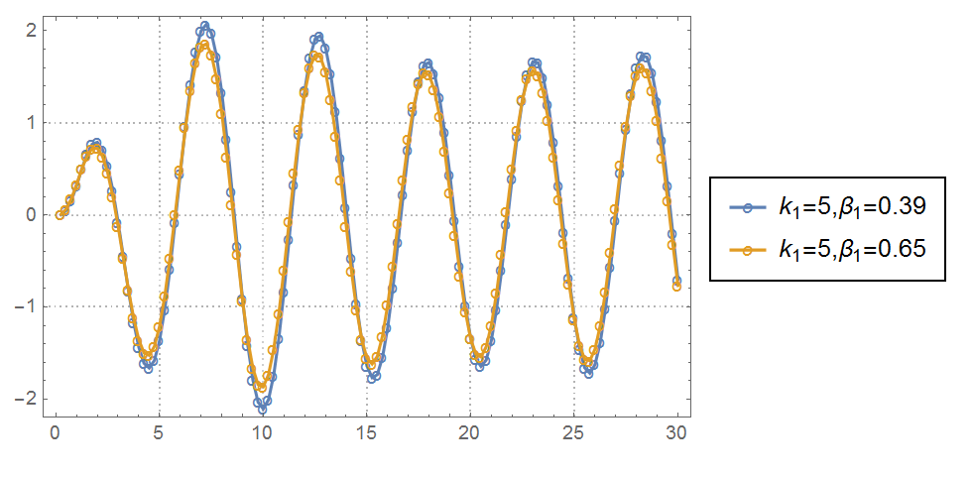

* the following figure gives with respect to time :

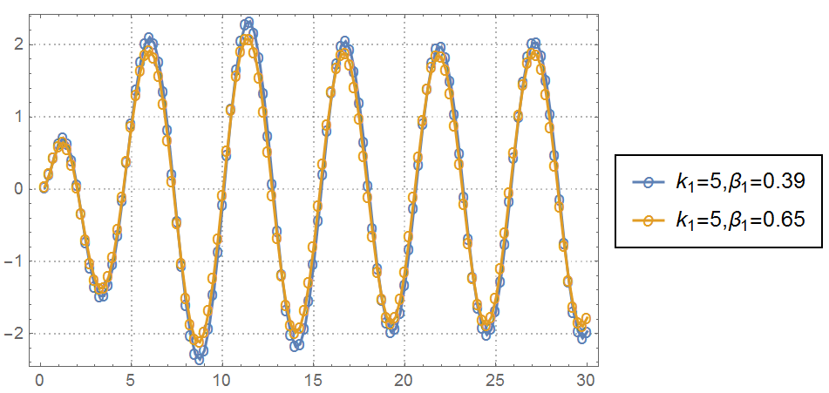

**For ,**

* the following figure gives with respect to time :

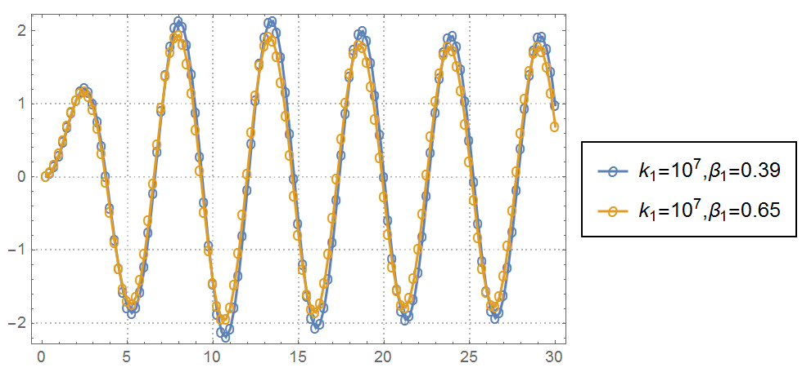

* the following figure gives with respect to time :

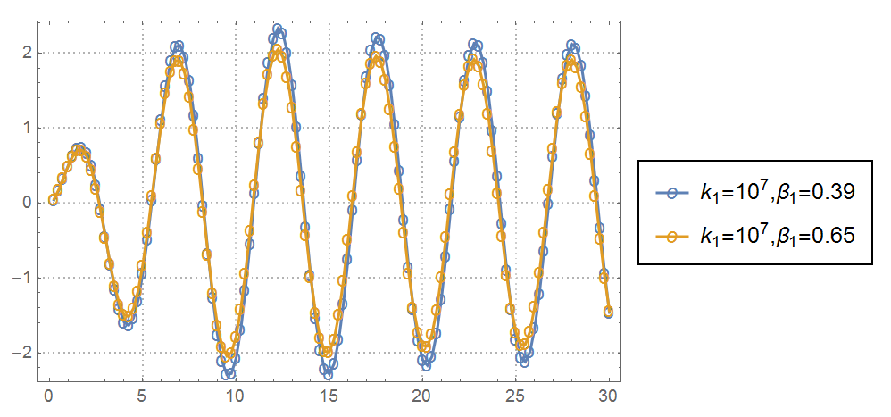

* the following figure gives with respect to time :

